**Chapter 4:**

**Introduction to Differential Equations**

**4.2 Direction Fields and Numerical Methods**

**Section Exercises**

**For the following problems, use the direction field below from the differential equation Sketch the graph of the solution for the given initial conditions.**

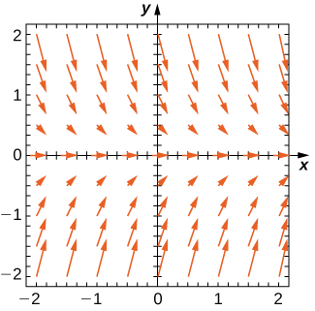

67. 

Answer:

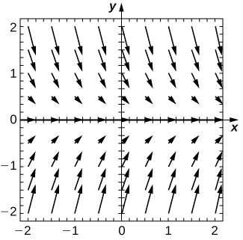

69. Are there any equilibria? What are their stabilities?

Answer:  is a stable equilibrium

**For the following problems, use the direction field below from the differential equation Sketch the graph of the solution for the given initial conditions.**

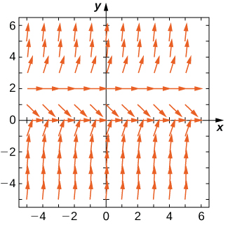

71. 

Answer:

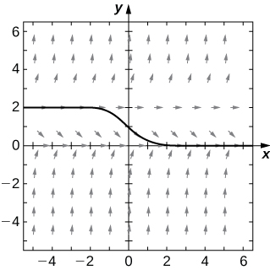

73. Are there any equilibria? What are their stabilities?

Answer: is a stable equilibrium andis unstable

**Draw the direction field for the following differential equations, then solve the differential equation. Draw your solution on top of the direction field. Does your solution follow along the arrows on your direction field?**

75. 

Answer:

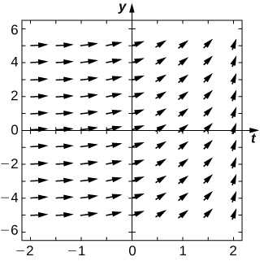

77. 

Answer:

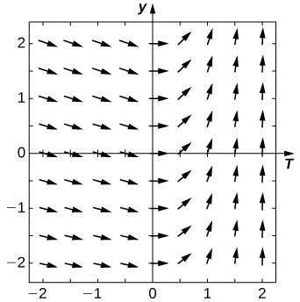

**Draw the directional field for the following differential equations. What can you say about the behavior of the solution? Are there equilibria? What stability do these equilibria have?**

79. 

Answer:

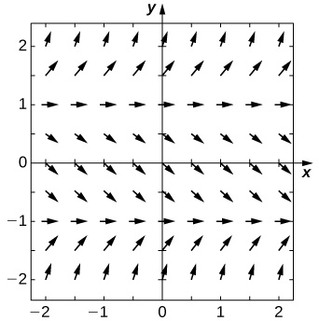

81. 

Answer:

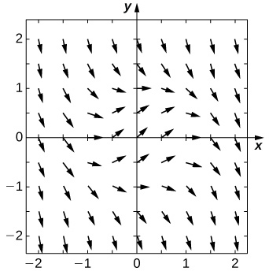

83. 

Answer:

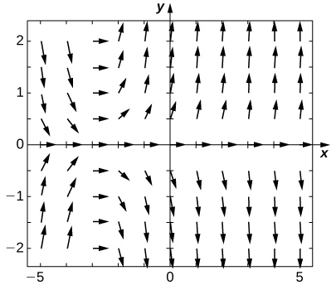

**Match the direction field with the given differential equations. Explain your selections.**

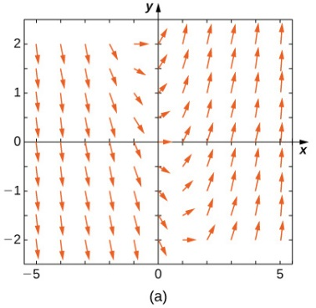

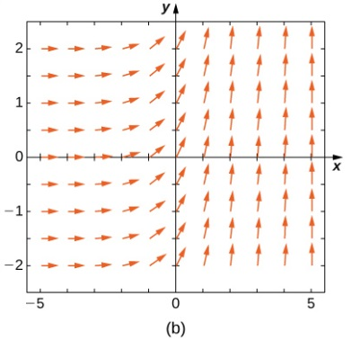

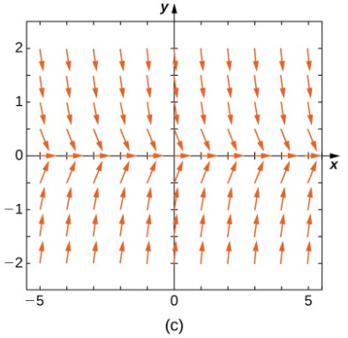

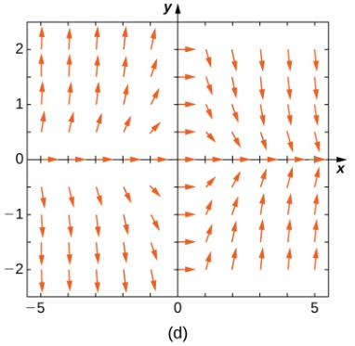

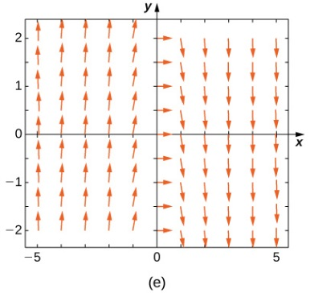

85. 

Answer: e

87. 

Answer: a

**Match the direction field with the given differential equations. Explain your selections.**

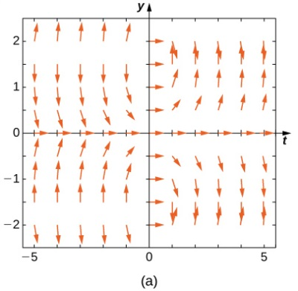

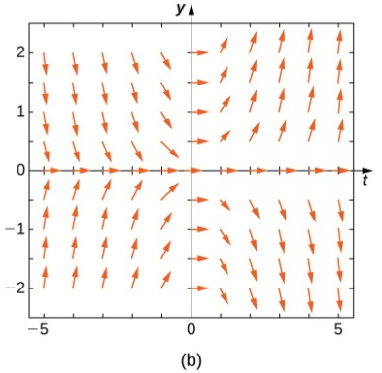

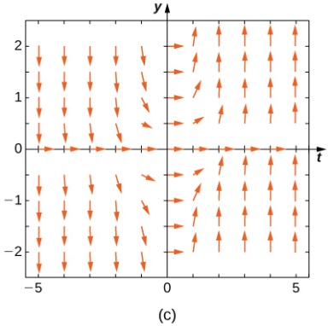

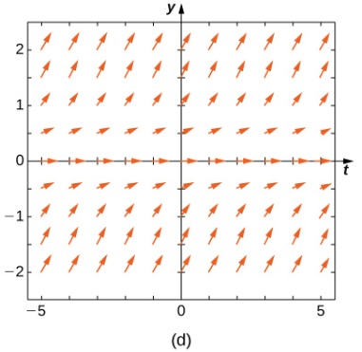

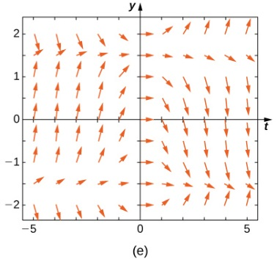

89. 

Answer: b

91. 

Answer: a

93. 

Answer: c

**Estimate the following solutions using Euler’s method with steps over the interval If you are able to solve the initial-value problem exactly, compare your solution with the exact solution. If you are unable to solve the initial-value problem, the exact solution will be provided for you to compare with Euler’s method. How accurate is Euler’s method?**

95. 

Answer: exact:

97.  Exact solution is 

Answer:  exact: 

99. **[T]** Exact solution is

Answer:  exact: 

101.  Exact solution is 

Answer:  exact: 

103. Exact solution is 

Answer:  exact: 

**Differential equations can be used to model In the next set of problems, we examine the change of size of two sub-populations of people living in a city: individuals who are infected and individuals who are susceptible to infection. represents the size of the susceptible population, and represents the size of the infected population. We assume that if a susceptible person interacts with an infected person, there is a probability that the susceptible person will become infected. Each infected person recovers from the infection at a rate and becomes susceptible again. We consider the case of influenza, where we assume that no one dies from the disease, so we assume that the total population size of the two sub-populations is a constant number, The differential equations that model these population sizes are**



**Here represents the contact rate and is the recovery rate.**

105. Assuming the parameters are and draw the resulting directional field.

Answer:

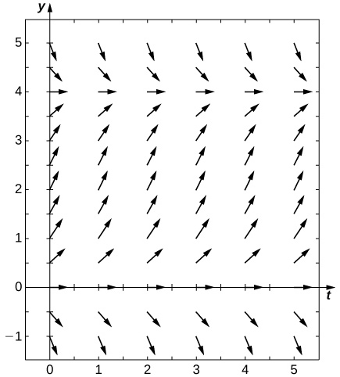

107. Solve the initial-value problem for the exact solution.

Answer: 

109. 

Answer: 

111. **[T]** 

Answer: 

113. **[T]** Evaluate the exact solution at Make a table of errors for the relative error between the Euler’s method solution and the exact solution. How much does the error change? Can you explain?

Answer: 

|  |  |
| --- | --- |
| Step Size | Error |
|  |  |
|  |  |
|  |  |
|  |  |

**Consider the initial-value problem**

115. Draw the directional field of this differential equation.

Answer:

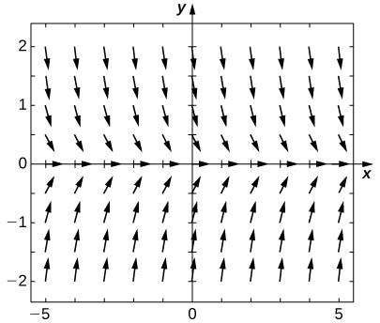

117. **[T]** By calculator or computer, approximate the solution using Euler’s Method at using

Answer: 

This file is copyright 2016, Rice University. All Rights Reserved.